**Script for YouTube Video: Open/Closed Principle (OCP)**

**[Opening Sequence]**

[Show title screen with vibrant background music and the title: "Mastering Open/Closed Principle in C#: Unlock Flexible and Extensible Code"]

**[Introduction]**

**Host**: "Hey everyone! Welcome back to [Your Channel Name]. In today’s episode of our SOLID principles series, we’re diving into the **Open/Closed Principle**, or OCP."

**Host**: "If you’ve ever faced issues where small changes in your codebase cause unexpected bugs or ripple effects, this principle is the solution you’ve been looking for. By the end of this video, you’ll know how to write flexible and extensible code in C# without compromising existing functionality. So, don’t forget to like and subscribe for more coding wisdom!"

**[Part 1: What is OCP?]**

**Host**: "The Open/Closed Principle is the second principle in SOLID. It states: ‘Software entities such as classes, modules, and functions should be open for extension but closed for modification.’"

[Display this text on-screen with a bold font.]

**Host**: "This means we should be able to add new functionality to our code without altering the existing code. Why? Because modifying existing code increases the risk of introducing bugs and breaking functionality."

**[Part 2: Real-Life Analogy]**

[Show visuals of a smartphone.]

**Host**: "Let’s take an example from everyday life. Think about a smartphone. When you want new functionality, like a new feature or app, you simply download an app from the app store. You don’t need to rebuild or change the phone’s operating system."

**Host**: "In the same way, our classes and modules should allow for new features without requiring us to rewrite the existing code."

**[Part 3: Example of Violating OCP]**

[Switch to Visual Studio or your preferred IDE.]

**Host**: "Let’s look at an example in C#. Suppose we have a class that calculates the area of different shapes. Here’s how it might look if we violate the Open/Closed Principle."

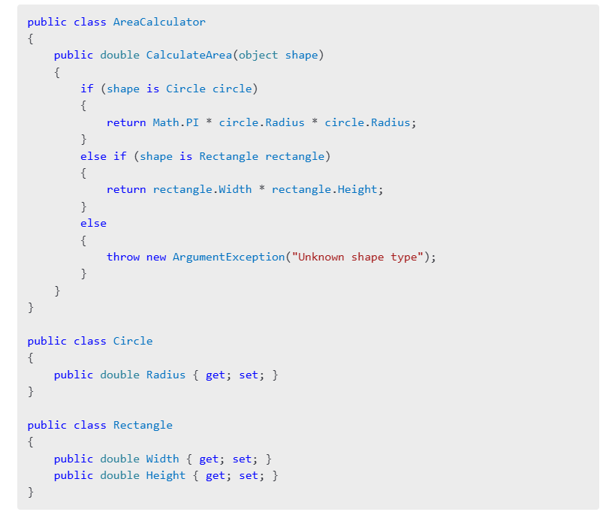**Host**: "Here, the CalculateArea method violates OCP. Every time we add a new shape, we’ll need to modify this method, increasing the risk of breaking existing functionality."

**[Part 4: Refactoring with OCP]**

**Host**: "Now, let’s refactor the code to follow the Open/Closed Principle. We’ll use polymorphism to extend functionality without changing existing code."

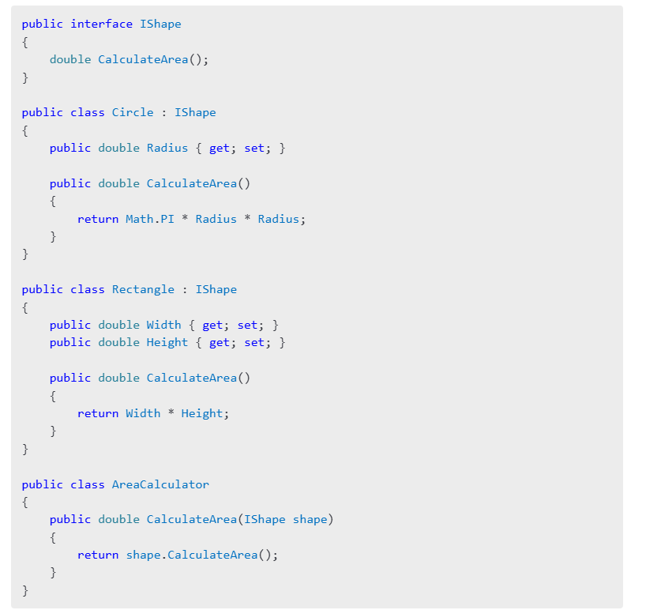

**Host**: "Now, when we add a new shape, like a triangle, we just create a new class implementing the IShape interface. No changes to the AreaCalculator class are needed. Let’s see how this works for a triangle."

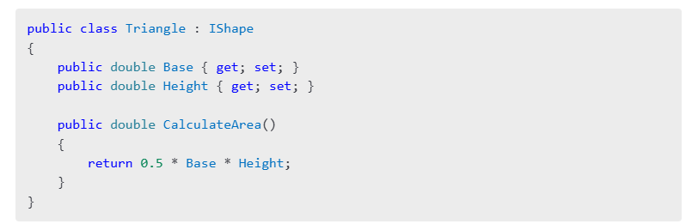

**Host**: "With this design, our code is now open for extension and closed for modification."

**[Part 5: Advantages and Disadvantages of OCP]**

**Host**: "Let’s quickly discuss the pros and cons of applying OCP in your projects."

**Advantages**:

* "Minimizes the risk of introducing bugs when adding new functionality."
* "Improves code readability and maintainability."
* "Encourages modular design."

**Disadvantages**:

* "Requires a good understanding of abstractions."
* "Can lead to over-engineering if applied unnecessarily."
* "Slightly increases the complexity of the initial design."

**[Part 6: Closing and Call-to-Action]**

**Host**: "To summarize, the Open/Closed Principle helps you create code that is easier to maintain, extend, and scale. By relying on abstractions and polymorphism, you can add new features without breaking existing functionality."

**Host**: "What do you think about OCP? Have you faced scenarios where modifying existing code caused unexpected bugs? Share your experiences in the comments below. And if you’re enjoying this SOLID principles series, please like, subscribe, and hit the notification bell."

**Host**: "Thank you for watching, and stay tuned for our next video, where we’ll explore the **Liskov Substitution Principle**!"

[End with upbeat music and your channel logo.]

**[On-Screen Text Suggestions]**

1. "Key Takeaway: Extend functionality without modifying existing code."
2. "Polymorphism: The secret to following OCP."
3. "Coming up next: Liskov Substitution Principle."

**Suggested B-Roll and Visuals**

1. **Animations**: Show a class "evolving" to handle new shapes without modifying existing code.
2. **Text Popups**: Display advantages/disadvantages as the host explains them.
3. **Code Highlighting**: Focus on problem areas in the "violating OCP" example.

Let me know if you need further edits or additional resources for this script!